Assessment of the Socioeconomic Factors of Environmental Change of the Local Communities in Suakin and Tokar Localities, Red Sea State
DRAFT No 0
Nahid Abdel Rahim Osman Department of Coastal Management, Faculty of Marine Science and Fisheries, Red Sea University, Port Sudan, Sudan.

Summary
This is an assessment of some socioeconomic factors of environmental change at the study site. The overall objective of this survey was to assess socioeconomic factors that may support the establishment of a marine protected area (MPA) south of Suakin. All the livelihood in the sites are artisanal and informal depending completely on natural resources. Farming, fishing, and pastoralism are the main livelihoods. Recently, charcoal making and firewood collection have emerged as new and wide spread livelihoods due to the invasion of mesquite trees to the area. Infrastructure and services are lacking. The study area deserves to be designated as a MPA for the following reasons:
- The level of environmental degradation in the study area is remarkable as is evident by: sand drift, invasion of mesquite trees, degradation of natural vegetation, and the extensive extraction of Dufra. This situation required urgent implementation of environmental protection measures.
- The area is clean of pollution except for the solid domestic waste that could be control. No major sources of air and liquid pollution (e.g. factories) do exist in the area, vehicles are the main source of air pollution at the survey time.
- Shift in livelihood from farming and fishing to charcoal making, indirectly indicates the degradation in the general environmental conditions of the study area, which need urgent interventions,
- Loss of natural resources due to environmental change. Particularly, loss of farm land and rangeland,
- The artisanal life of the ethnically diverse local communities represents a unique example of indigenous ecological and environmental knowledge on natural resources utilization and preservation
- The presence of Delta Tokar as a unique geomorphological area in the entire Red Sea region and as a vital asset for subsistence livelihood for the local community.
- The rich, dense, and intact mangrove stands, seagrass meadows, and seaweed patches which contribute to the fisheries diversity of the study area should be managed sustainably for future generations.

The type of the MPA to be established in the study area should be carefully selected to suite the socioeconomic setting of the area. In this regard, the designation of protected zones (PZ) within the broader area of south Suakin could be considered.
The assessment recommend to design and implement an awareness programme on MPA enhance the awareness of the community and to undertake a detailed survey on the demographic conditions and characteristics of the local communities in the study sites with special attention to women.

Introduction
Socioeconomic assessment is vital to environmental management process. The interaction between socioeconomic activities and the environment is reciprocal. Therefore, it is imperative to identify socioeconomic activities and their associated environmental changes at earlier stages of environmental management.
The rich and diverse coastal habitats of the area south of Suakin has been recognized and the area was recommended as a Ramsar Site due to the extensive mangroves, birds, and turtles populations reported for the area. Also, an area to the east of Tokar was designated as a reserve since the 19th century. To date, the area still lacks any kind of environmental protection or management.
In this era of climate change, the need to undertake responsible and scientific sound environmental measures is imperative to conserve the human environment. Areas such as south Suakin deserve to be preserved to keep the integrity of the coastal environment, and to maintain the services provided by these ecosystems to human.
Scope of the socioeconomic assessment
This is an assessment on some socioeconomic factors of environmental change at the study site. It was carried out at the level of key informant (KI) and aimed to assess the general conditions of livelihoods, resource use, environment, infrastructures and services. Additionally, it also aimed to identify specific gaps in socioeconomic status of the study area for further comprehensive survey.
Objectives
The overall objective of this survey is to assess socioeconomic factors that may support the establishment of a marine protected area (MPA) south of Suakin. Specifically, the survey aimed to:
- To document the current situation of key infrastructures and services,
- To document livelihoods types and resources utilization,
- To recommend future socioeconomic indicators to monitor changes due to development interventions.
Methodology
Firstly, available literature on the socioeconomic conditions of the study area was reviewed and some missing information was identified and included in the study tools. The study area was visited from Tuesday March 29th to Saturday April 1st 2022. The information required for this assessment were obtained with the 2 following methods:
Semi-structured interviews: A semi-structured interview for key informant(s) was designed according to the guidelines described in Abdrabo and Hassan (2003); Bellu and Pansini (2009), and Wilson (2014). The interview contained 26 preset open-ended questions to achieve the assessment objectives and a section on description of the surrounding environment undertaken by the interviewer. The question of the Semi-structured interview could be categorized as follow:
Site information, KI information, livelihood types, natural resources use, services and infrastructures, ethnic diversity, general characteristic of the surrounding environment.
Observation
Additional information on livelihoods, housing, natural environment, paved roads, sanitation, waste collection, public transportation, markets was obtained by observing the surroundings of the villages/marsas while walking or driving by car.
Assessment sites
The assessment was carried out from marsa Oboug immediately south of Suakin port to Tokar town (Table 1 and Fig. 1 & 2). Key informants (Table 2) were met in inhibited sites in Nolabab, Sheikh Saad, Airam, Seetrab, Ashat, and Tokar. The rest of the sites were uninhibited but used for livelihood-related activities. Some of these uninhibited marsa (Entabeeb, Argowad, Kashidamar, Alazmi Khor\Airam, Salah Island, and Trinkitat) were not accessible at the study time.

Table 1. Sites of the assessment of socioeconomic factors of environmental change in the study area South Suakin to Tokar.
Site name (Arabic) | Site name (English) | Coordinates | Habitats and Livelihood activities
اوبوق | Oboug | N: 18.41667° E: 37.71667° | Landing site, gleaning of Opercula of Lambis and Strombus mollusc species (Dufra).
انتابيب | Entabeeb | - | -
اللقاق (لقاقنبيب) | Al-Lagag | - | Mangrove stand, landing site, gleaning of Dufra
ارقواد | Argowad | - | --
هيدوب | Hydoub | 18º 59 52 N 37 º 24 18 E | Mangrove stand, landing site, public beach with fish restaurant, gleaning of Dufra, rest houses
كشيدامر | Kashidamar |  | --
شيخ إبراهيم | Sheikh Ibrahim | 18 º 53 20 N 37 º 24 47 E | Hydoub Port, Mangrove stand, gleaning of Dufra.
نولاباب | Nolabab village | 18 º 53 20 N 37 º 24 47 E | Semi-desert vegetation, charcoal making, fire wood collection, petty trading, workers at Hydoub Port.
شيخ سعد (تكرانياي) | Sheikh Saad (Tekranyai) | 18 º 51 21 N 37 º 25 34 E | Mangrove stand, landing site, gleaning of Dufra, fish restaurant, army camp site
تيقا | Teega | 18 º 50 51 N 37 º 26 18 E | Mangrove stand, gleaning of Dufra
خور العازمي او ايرم | Alazmi Khor\Airam |  | Mangrove stand, gleaning of Dufra
ايرم | Airam village | 18 º 50 24 N 37 º 26 00 E | Semi-desert vegetation, charcoal making, fire wood collection.
اشت | Ashat village | 18 º 44 37 N 37 º 30 50 E | Mangrove stand, gleaning of Dufra, fishing, charcoal making, fire wood collection.
جزيرة صلاح | Salah Island | 18 º 45 43 N 37 º 29 41 E | Mangrove stand, gleaning of Dufra
سيتراب | Seetrab
طوكر | Tokar town | 18º 25 31 N 37º 43 43 E | Deltaic, semi-desert vegetation, organic agriculture, animal husbandry, fishing, charcoal making, fire wood collection.
ترنكتات | Trinkitat |  | --

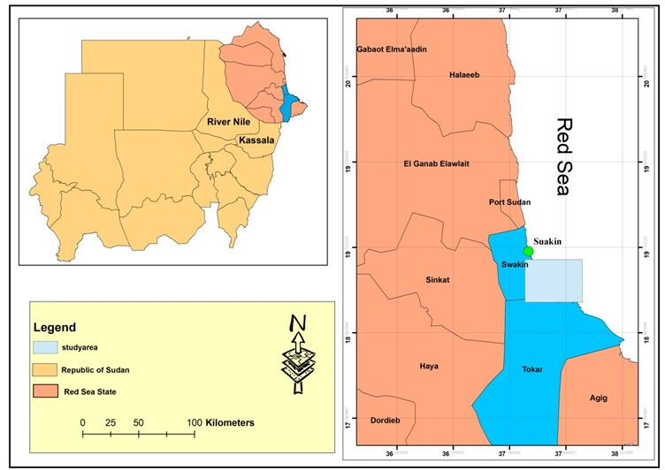
Fig. 1. The study area of the socioeconomic assessment.

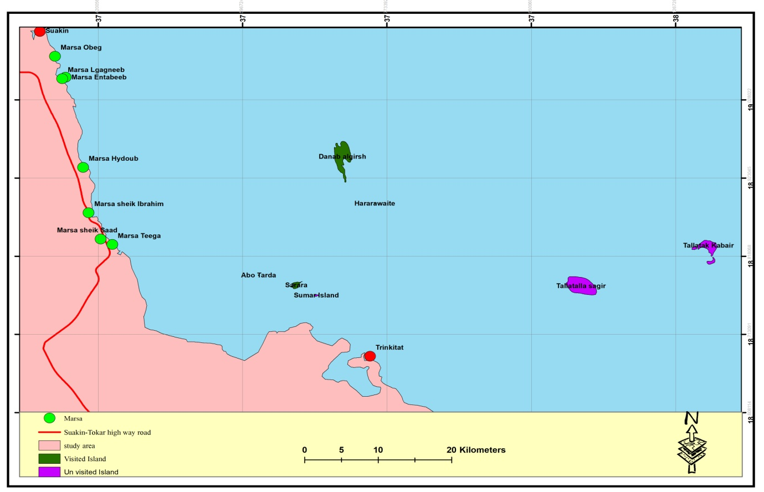
Fig. 2. Sites of the assessment of socioeconomic factors of environmental change in the study area South Suakin to Tokar.

Description of the major population centers at the study areas
The study area contains 3 major populated areas where socioeconomic activities are undertaken. These towns host a mix of ethnic groups who utilise the natural resources of the area according to customary laws.
Airam: is small village belong to Suakin Locality. It is located south of Suakin at about 40 km. The village contain a primary school, a women center, and a youth center. The following mix of tribes resides in Airam: Norab, Shiab, Kimilab, Ababda, and Rashida.
Ashat: is located south about 53 km south of Suakin and north west of Tokar in Tokar Locality. Ashat is relatively larger than Airam. It hosts some governmental institutions including tax and zakat offices besides a police station. The local market of Ashat is relatively larger than Airam`s market and it contains small stalls. Only 2 tribes, Trik and Gamilab, reside in Ashat.
Seetrab: Seetrab village is 66 km south of Suakin in Tokar Locality, is the major source of freshwater to the entire area south of Suakin. Two wells are present in the village both are operated with solar energy units. The solar system of one of the wells is in need of repair. Water tankers, owned by individuals, transport the water to the surrounding areas. The local market of the village is located next to the road to serve the village and travelers. Small shops sell food, vegetables, charcoal, firewood, soft drinks, and other petty trade items.
Tokar town has a unique geomorphological location (N: 18.41667° E: 37.71667°). It is located at the delta of Khor Baraka or Baraka seasonal stream in the south eastern part of the RSS in Tokar Locality. Tokar is connected to Suakin with a road which serve both localities. The delta is the only known in the entire Red Sea region. Tokar is located in the center of the delta at about 145 k and 90 k south of Port Sudan and Suakin, respectively. The major economic activity in Tokar is the Tokar Agricultural Project. established in the eighteenth century mainly for cotton plantation and other crops. Accordingly, of Tokar 170000 inhabitants about 73% are farmers and only 27% are practicing activities related to animal rearing.
Tokar community is very diverse with ethnic groups from around the country. Examples of these groups are: Berno, Hedandawa, Beni Amer, Habab, Rashida, Nuba, and Sudania.

Results and discussion
The semi-structured interview was conducted at 5 sites (Table) with a group of 2-3 KIs of each site. Besides, personal communication was also done with KI such as the president of Tokar Farmers Union and fisher sheikh. The findings extracted from these interviews were presented in Tables 2 to 7.

Table 2. Main assessment sites and contact details of key informants.
Site | KI | Job | Contact
Nolabab | Seid Ahmed Abuhesain. | fishers & charcoal makers | +249916346957
 | Ahmed Hassan Taha. |  | NA
Sheikh Saad | Mohamed Abdallah (Dabaloob) | Fisher & restaurant owner
Airam | Moha Deen Talab. | Volunteer teacher | +249918056425.
 | Hassan Moh. Moh. Othman. | Teacher & Emam | +2499163783033
Ashat | Moh. Moh Onour Adam | Inspector, Tokar locality | +249914730248
Tokar | Attbai Hamed | Account officer, Tokar locality & Nazir. | +249914608354.
Tokar | Abdallah Moh. Ahmed abuamna | Farmers leader | +249904372508
Tokar | Ahmed Mahmoud Ausam | Fishers leader | +24910772460
Tokar | Wanab Osman Abufatima | Pastoralist leader | +24915175050

Livelihoods types
Farming, fishing, charcoal making, and livestock rearing are the major livelihoods in the assessment sites (Table 3 and Fig.3). Most of the individuals of the local communities of the assessment sites practice 2 to 3 livelihoods simultaneously as a coping strategy to increase their income. The majority of these livelihoods are artisanal, informal/self-employed, and exclusively dependent on extraction of natural resources. Very few formal/governmental jobs are available to communities in primary education, locality office, police, harbour, primary health care in Airam, Ashat, and Tokar.
Information on statistics of the individuals who practice each livelihood activity is not available officially due to absence of formal professional associations.

Table 3. Livelihoods* of the local communities in the study area.
Livelihoods | Sites
 | Nolabab | Sheikh Saad | Airam | Ashat | Tokar
Fishers | 20 | 1 | 50 | 0 | 200
Farmers | 55 | 0 | 2000 | 2970 | 82000
Charcoal makers/fire wood collectors | 26 | 0 | 200 | 4950 | Unknown
Animal rearing | 0 | 0 | 50 | 330 | Unknown
Teachers | 0 | 0 |  |  | 450
Petty traders | 2 | 0 | 6 | 8 | 20
Gathering of marketable natural products#. | 0 | 0 | 0 | 2 | 9
Officers | 0 | 0 | 10 | 11 | 18
Others | 9 | 2 | - | - | -
Population** | 275 | 3 | 5500 | 6600 | 170000
*: Numbers are not final and are the KI`s estimate.
#: observed in Ashat and Tokar markets but it is a common practice in Sudan.
**: Estimated based on the number of houses and the average size of family.

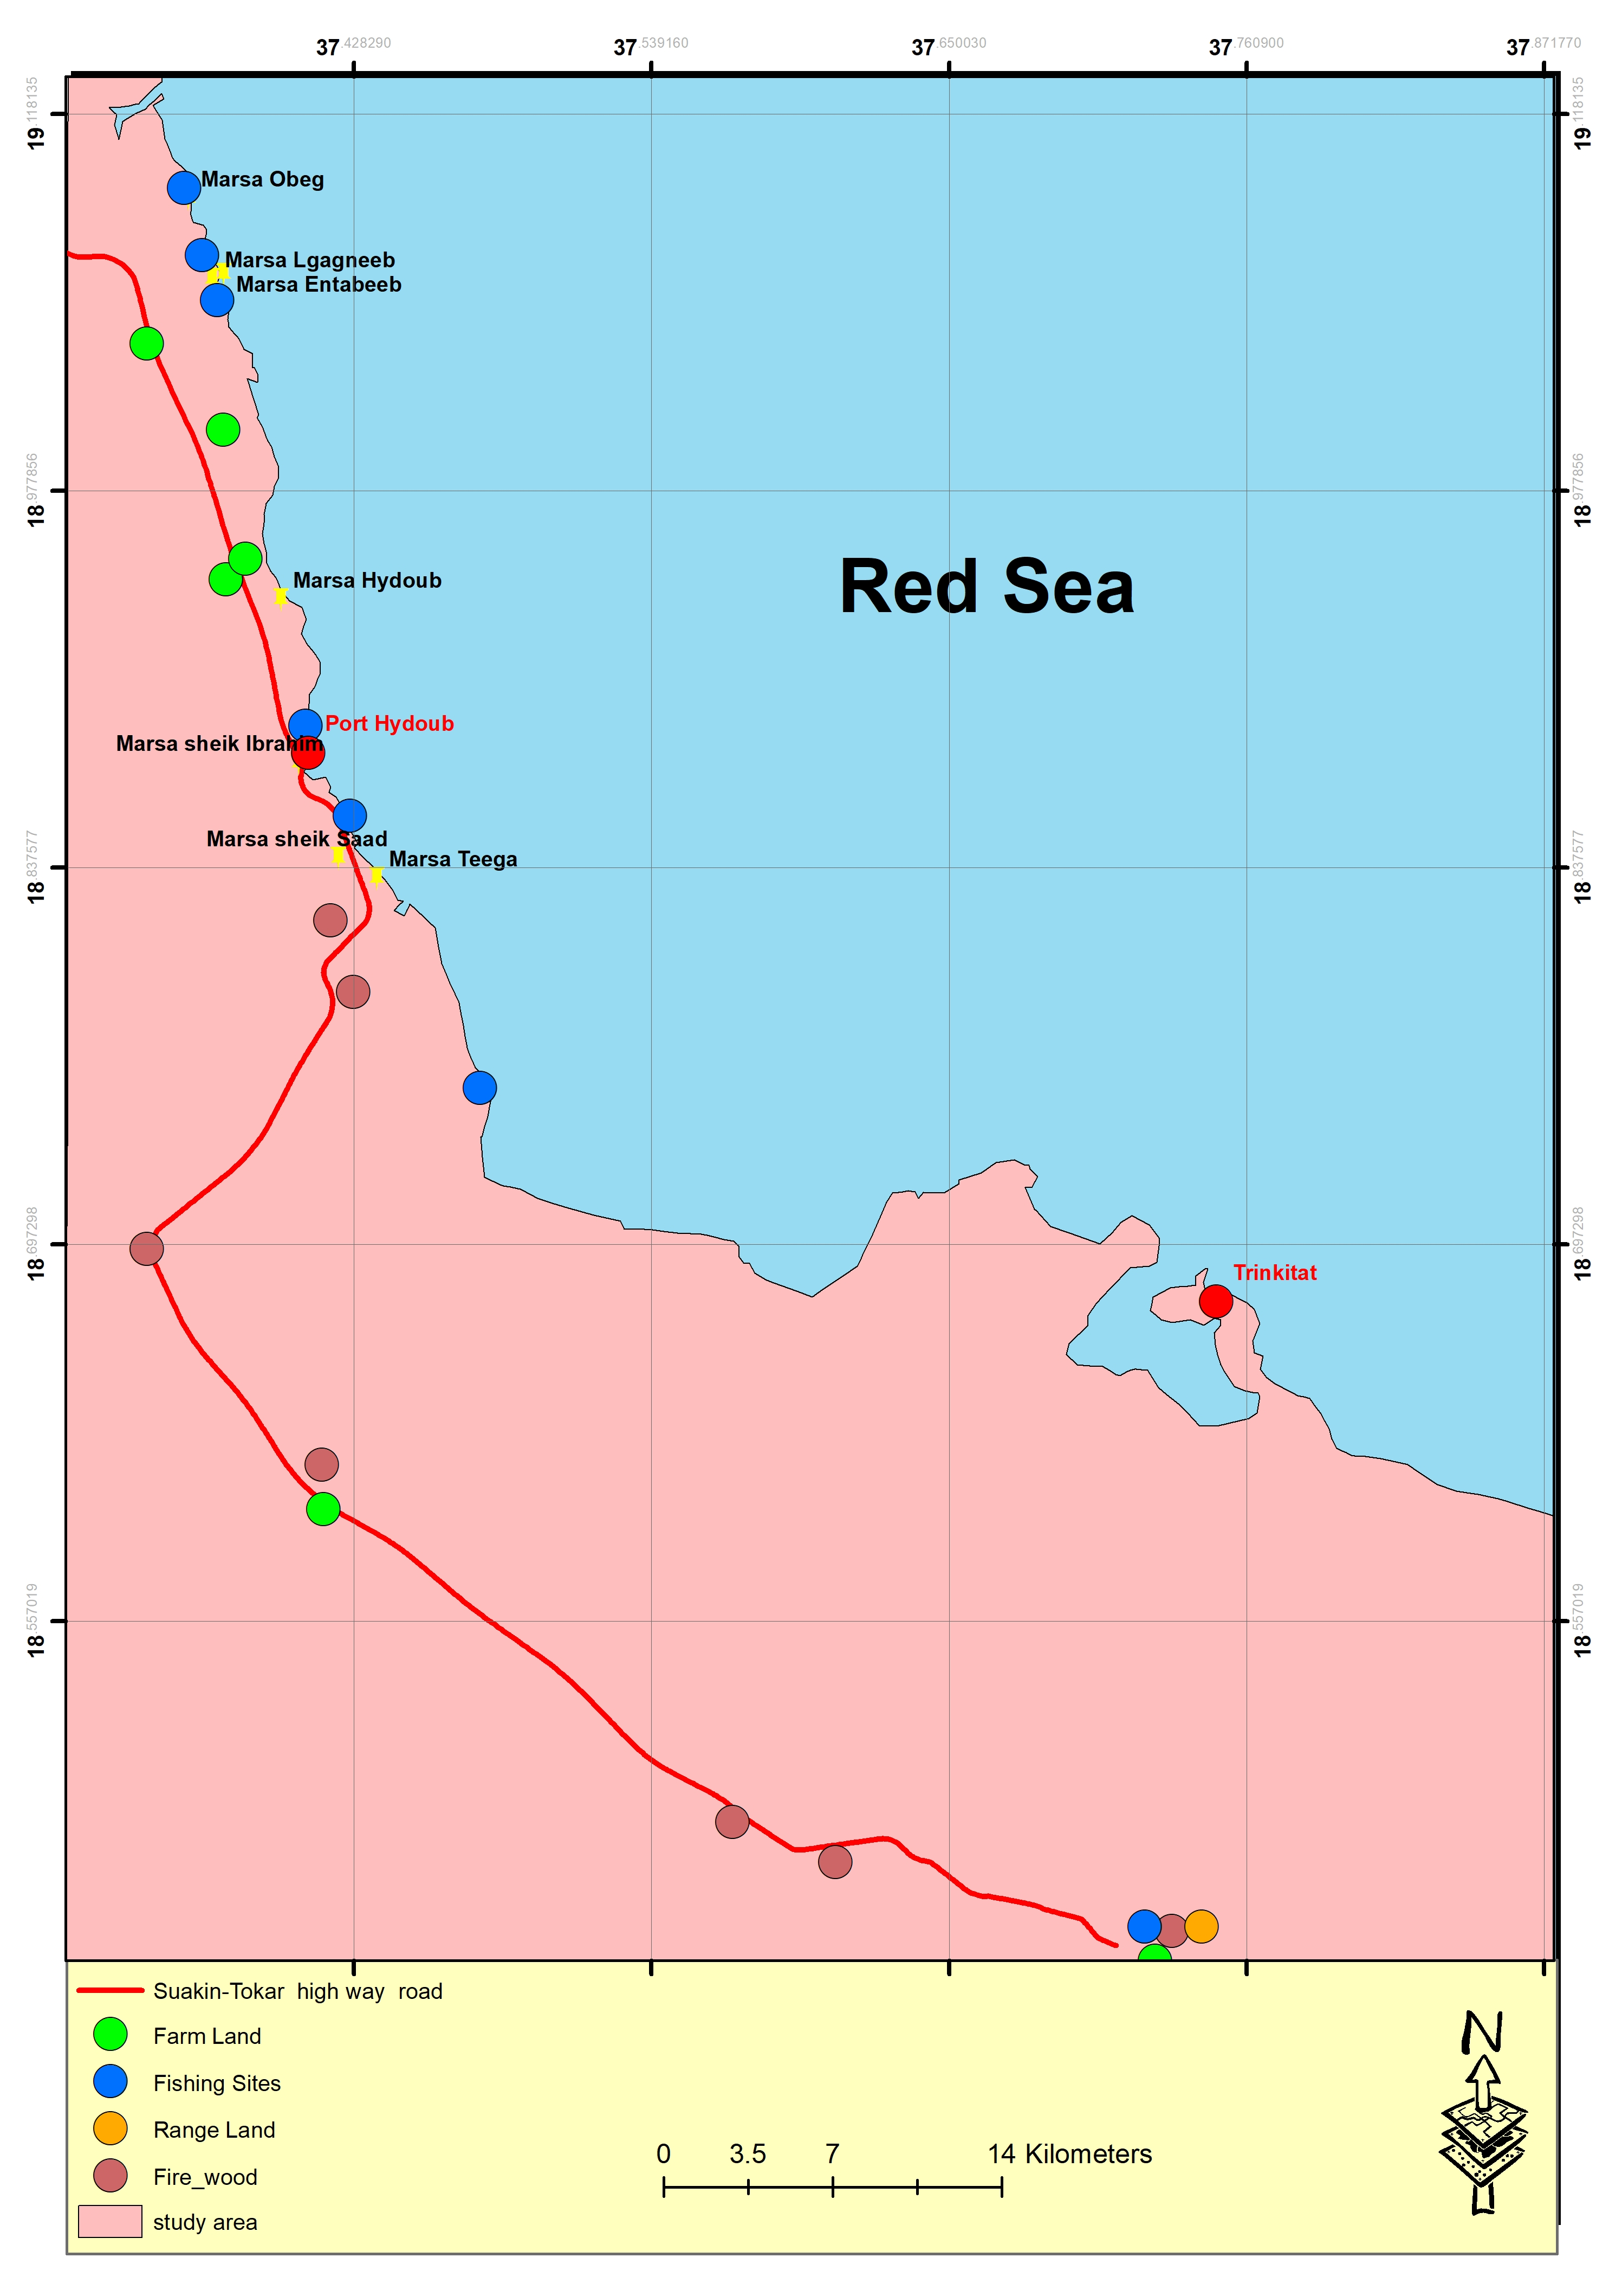
Fig.3. Sites of major livelihoods in the study area.

Fishing: Fishers exploit more than one fishery depending on the season. They can exploit finfish or glean the opercula of Lambis and Strombus mollusc species (Dufra). The latter is heavily exploited as indicated by the extensive heaps of the animal shells at all mangrove stands of the study area. Fishing is practiced with artisanal gears including hook and lines and nets.
Farming: delta Tokar is the farming land for the entire study area. However, subsistence farming is seasonally practiced in some marginal lands at Tahili north of Nolabab and in low lying spots on both side of the road. The main crops farmed are millet and water melons.
Charcoal making and firewood collection: most of the local community has changed their livelihood to charcoal making and firewood collection due to the extensive invasion of mesquites to the area including delta Tokar. This livelihood seems to dominate the informal labour market of the study area as is evident by the increasing number of the charcoals overloaded tracks moving on the road and the remarkable volume of charcoal sacks at the charcoal marketplace. Any individual can collect mesquite wood from around the village and sell it to charcoal makers with acceptable price. Camps of charcoal making were observed inside the dense stands of mesquite trees in the western delta Tokar.
Gleaning of marketable natural products: is a common practice of Beja natives. Nabag (fruits of Ziziphus spina-christi), of muswak (sticks of salvadora persica), and doom (fruits of Hyphaene thebaica) are the common products sold.
Selling of water: selling of water as a livelihood is now a wide spread practice all over the Sudan due to lack of water supply systems. In the study area, water is transported by tankers and carts pulled by monkeys to be sold or delivered to public institutions. An individual who practice this livelihood is known as Sagga in the RSS (plural saggaieen). No formal estimation of people working as sagga is available yet.
Petty trading: petty traders are commonly encountered along the road and in villages local markets. Petty trading is the selling light weight, small size, and consumable goods such batteries, facial tissue, and gum.

Major economic schemes in the study area
The study area is greatly underdeveloped and the economy is dominated by conventional and informal livelihoods. However, some small to median economic projects are established in the area which could provide employment for the local community.
- Delta Tokar agricultural scheme
The scheme was established in delta Tokar with an area of 406000 feddans for cotton plantation. The delta land is naturally fertile and annually renewed and this eliminate the use of fertilizers making the agriculture there completely organic. Now, the scheme provides a mix of crops mainly tomatoes, eggplants, onions, and grains. The size of the area farmed in the scheme varies annually, depending on the volume and the extend of the flow of the water discharged by Barak stream. The scheme suffers from 2 major problems that affect the livelihood of the farmers. The first is the fluctuation in Baraka discharge and the second is the invasion of mesquite trees all over the delta. The scheme composed of 3 sections as follows:
The eastern delta: the total area is 125000 feddans and the arable area is about 30000 feddans. The arable land is divided into 785 agricultural blocks. The remaining land is occupied by sand dunes and mesquite trees.
The middle delta: This is the most fertile part of Tokar delta that is naturally irrigated with the flood water even during low seasons. Due to continued flooding with heavily silted water of khor Baraka the middle delta is elevated compared to the other 2 parts of the delta. It`s total area is about 167000 feddans and the arable land account for 87000 feddans divided into 1036 blocks. The remaining land is also infested by mesquite trees and sand dunes; however, it is arable if cleared and prepared for agriculture.
The western delta: the total area of the western delta is about 128000 feddans of which 100000 feddans are arable land. The arable land is allocated into 800 blocks. This part is fully infested with Sueada plants and sand dune that impede flooding water. Therefore, it has been abandoned but could be farmed if prepared well for agriculture.
- Hydoub port for livestock export
Hydoub port is located 24 k south of Suakin and was officially inaugurated in 2017. To export livestock (including fish) and vegetables. It contains 5 piers with different handling capacities between 10.000 to 30.000 tons. The 16 cattle sheds were designed to accommodate 30.000 animal heads. Besides, the port contains a power station and a desalination unit. Nevertheless, the incompletion of the veterinary quarry impedes the exportation from the port which is inactive now. Therefore, the anticipated economic growth of Hydoub and adjoining area was not attained. Yet, the port supplies the nearby settlements with water from its desalination unit.
- Picnicking
Sheikh Ibrahim and Sheikh Saad are 2 popular picnicking sites where sea food, mainly fish, is provided in a traditional way by one small food shop at each site. The 2 sites are visited by residents of the RSS as well as by the visitors from other states. The potential to develop and organize this environmentally friendly activity to enhance the local economic is significant.
- The slaughterhouse
The slaughterhouse is located at the southern outer skirt of Suakin harbour. Due to technical and some logistic issues the facility is abandoned now.
- The charcoal`s market
The charcoal market is located northwest of Tokar along the road at N: 18 º 29 18 E: 37 º 34 09. it is an open space where all the charcoal made in Dolabia, Marafeet, Egaieb, Fraxlaib, Handait, Tokar, Garora, Agig, and Adleiai is collected and transported to other states.

Living conditions
The RSS is one of the poorest regions of the Sudan. Adverse administrative and governmental policies, political instability, the arid climate, the recurrent drought spills have significant bearing on overall and socioeconomic development of the state. Of all services and infrastructures, the RSS suffers from chronic shortages in water supply especially during summer season (May to October) due to complete dependence on winter rainfall as the sole source of freshwater. Similarly, infrastructures required for energy (electricity and cooking gas), transportation, education, and health are very poor. These conditions have significant impacts on economic growth and the environment.

Services
The study area has extremely poor or non-existent basic services and infrastructures (Table 5).
Water sources and supply: The water service in all assessment sites is completely lacking. No public supply is available in the region and at the survey time almost all the sites depend largely on one well in Seetrab village (Table 4) as the other one is in need of repair. While water sources are maintained by the government, water supply or distribution is undertaken by informal sector. Residents have to buy their water with high prices from vendors. The jerry cans (USG 300/pair) and barrel (USG 1000) are used as selling units. The exception is Nolabab where water is provided for free from the desalination unit of Hydoub Port.
It is notable that some major water resources (e.g. the wells of Airam and Seetrab and one of the pipelines in Tokar) are presently out of service and in need of repair. Maintenance of these water sources will mitigate the severity of water shortages in the area.
Table 4. Distance from the major source of water to assessment sites.
Site | Distance to Seetrab well (km)
Airam | 26.475
Ashat | 13.475
Tokar | 39.200

Table 5. Status of the basic services and infrastructures in assessment sites.
Service | Sites
 | Nolabab | Sheikh Saad | Airam | Ashat | Tokar
Water resources | Desalination unit of Hydoub Port | Seetrab well | Airam well, desalination unit (inoperative), Seetrab well | 2 salty wells, Seetrab well | Krnbeet Water Station, Seetrab well
Water supply | Underground tanks (3) for water storage | Tankers from Seetrab well. | Tankers from Seetrab well and Desalination unit of Hydoub Port | Tankers from Seetrab well | Partial pipeline supply
Electricity | NA | NA | NA | NA | 80% coverage
Cooking fuel | Charcoal and firewood | Charcoal and firewood | Charcoal and firewood | Charcoal and firewood | Gas, charcoal and firewood
Health center | NA, Suakin | NA, Airm | Health center | Health center | General hospital
Transportation | NA | NA | NA | NA | Available
Primary Schools | NA | Available | available | Available | Available
Women/youth centers | NA | NA | available | Available | NA
Cellular coverage | Available | Available | available | Available | Available
Markets | NA | NA | available | Available | Available
Police station | NA | NA | available | Available | Available

Electricity: No public electricity services are present except for Tokar where only 20% of the city remain to receive the service. Solar energy units were introduced as an energy source for some wells and institutions by government and some NGOs. Some of these units are in need of repair. Privately-owned diesel engines were also noticed in Ashat and Tokar.
Cooking fuel: the local communities of the assessment site depend exclusively on charcoal and firewood as energy source. Now, almost all the charcoal and firewood are obtained from mesquite trees. Key informants at all sites stated that charcoal used to be made from Acacia tortlis tree (locally known as sanganeb), but the excessive cutting of the tree, the drought, and the invasion of mesquites have remarkably diminished the tree density. Exclusive dependence on charcoal and firewood as cooling fuel represent cause remarkable degradation to the natural vegetation cover and aggravate climate-related problems. Sustainable energy sources are urgently needed as one of the measures to restore the natural vegetation cover.
Health care services: despite the presence of health centers in Airam and Ashat and the general hospital in Tokar, the service provided is very poor. These institutions are short-staffed, ill-equipped, and the medical staff is not well trained except for midwifes who can handle normal birth case. For serious ailment cases, local community members have to reach for Suakin or Port Sudan.
Primary education and cellular coverage: These 2 services are the best services in the study sites. Though the schools are in need of some equipment such as proper desks and boards, but the service is fairly maintained.
Transportation: all the assessment sites depends on one traffic line Port Sudan-Tokar-Port Sudan. The service is run privately by individuals who own vehicles suitable for transportation.
Markets (Sooq): petty trading in small markets is dominant in all the assessment sites visited.
Housing conditions
Houses in the old villages of Airm, Ashat and in Nolabab and the out skirt of Tokar are built from local unendurable materials such as straw mats, tree branches, and scrap materials (Table 6). Introduction of pit latrines to the area was recently encouraged by the Red Crescent Society.
Table 6. Construction materials and sanitation of the houses in the assessment sites
Site | Housing conditions
 | Construction materials | Sanitation
Nolabab | Straw mats and plant branches | Pit latrine
Sheikh Saad | Wood shingles | Pit latrine
Old Airam | straw mats and plant branches | Pit latrine
New Airam | Caravans | Pit latrine
Old Ashat | Straw mats and plant branches | Pit latrine
New ashat | Caravans | Pit latrine
Old Tokar | Mud, straw mats and plant branches | Pit latrine
New Tokar | Caravans | Pit latrine

Resource use and accessibility
The utilization of natural resources by the local community of the assessment sites is restricted to the nearby habitats around the village (Table 7). Access and use of resources is greatly impacted by the lack of means of transportation. Almost all the individuals move on foot, monkeys, camels, or take the transportation. Rashida tribe members own different type of vehicles and motorcycles.
Table 7. Nearest natural resources to the assessment sites
Site | Resources
 | Mangrove | Coral | Range land | Farm land
Nolabab | Sheikh Ibrahim | NA | Around Nolabab | Taheli
Sheikh Saad | Tega | NA | NA | NA
Airam | Airm and Ashat | NA | Around Airam | Near the Slaughter, on both sides of the road.
Ashat | Airm and Ashat | NA | Around Ashat, Baraka and khor Gash in summer | Ashat, Tokar, Seetrab.
Tokar | Agig | Trinkitat, | Around Delta Tokar Agricultural Scheme and khor Gash in summer | Delta Tokar Agricultural Scheme

Perception of the local community on protected area
- Awareness level: the knowledge of the local community on the meaning, purposes, and benefits of marine protected area (MPA) is negligible. One of the KIs said that he knows some information about MPA in Eritrea from the radio.
- Almost all the KIs stated that they would accept the establishment of a MPA in their region only if it would serve the interest of the community.
Conclusion
The study area deserves to be designated as MPA for the following reasons:
- The level of environmental degradation in the study area is remarkable as is evident by: sand drift, invasion of mesquite trees, degradation of natural vegetation, and the extensive extraction of Dufra. This situation required urgent implementation of environmental protection measures.
- The area is clean of pollution except for the solid domestic waste that could be control. No major sources of air and liquid pollution (e.g. factories) do exist in the area, vehicles are the main source of air pollution at the survey time.
- Shift in livelihood from farming and fishing to charcoal making, indirectly indicates the degradation in the general environmental conditions of the study area, which need urgent interventions,
- Loss of natural resources due to environmental change. Particularly, loss of farm land and rangeland,
- The artisanal life of the ethnically diverse local communities represents a unique example of indigenous ecological and environmental knowledge on natural resources utilization and preservation
- The presence of Delta Tokar as a unique geomorphological area in the entire Red Sea region and as a vital asset for subsistence livelihood for the local community.
- The rich, dense, and intact mangrove stands, seagrass meadows, and seaweed patches which contribute to the fisheries diversity of the study area should be managed sustainably for future generations.
- The type of the MPA to be established in the study area should be carefully selected to suite the socioeconomic setting of the area. In this regard, the designation of protected zones (PZ) within the broader area of south Suakin could be considered.

Recommendations
- Well deigned awareness programme on MPA should be implemented to enhance the awareness of the community.
- survey of the demographic conditions and characteristics of the local communities in the study sites with special attention to women should be undertaken.

References
Abdrabo MA and Hassan MA. 2003. A manual for Socioeconomic Study. Centre for Environment and Development for the Arab Region and Europe, (Cedare).
Bellu GL and Pansini RV. 2009. Quantitative SocioEconomic Policy Impact Analysis: A Methodological Introduction. Food and Agriculture Organization of the United Nation. Italy
Wilson, C. 2014. Semi-Structured Interviews. In: Interview Techniques for UX Practitioners Editor(s): Wilson, C.. 23-41. https://doi.org/10.1016/B978-0-12-410393-1.00002-8.
Ismael, M., Mokhtar, A., Farooq, M., & Lü, X. (2021). Assessing drinking water quality based on physical, chemical and microbial parameters in the Red Sea State, Sudan using a combination of water quality index and artificial neural network model. Groundwater for Sustainable Development, 14, 100612. doi: 10.1016/j.gsd.2021.100612

List of wildlife
Tokar | Nolabab | Airam | Ashat
حلوف | ثعلب | غزلان | غزلان
ثعلب | ارانب | ارانب | ارانب
مرفعين |  | مرفعين | مرفعين
ارانب |  |  | ثعلب
غزلان

